6115-MAHENDRA INSTITUTE OF ENGINEERING AND TECHNOLOGY

**Smart Water Fountain**

INNOVATION

**TEAM:proj_223281_Team_1**

TEAM ID:561

**TEAM MEMBERS:**

ARUNKUMAR R

ANTONY EDWIN V

ARISH S

BALAMURUGAN K

BALAMURUGAN U

**FACULTY MENTOR NAME:**

SANTHANARAJ M

DECLARATION:

We, the students of Computer Science and Engineering,

MAHENDRA INSITUTE OF ENGINEERING AND TECHNOLOGY,

TAMIL NADU

## that the work entitled " SMART WATER FOUNTAIN" has been successfully completedunder the guidance

of Asst Prof. Ms. santhana raja M,

Computer Science and Engineering Department,

mahendra institute of engineering and techonology , namakkal.

This dissertation work is submitted in partialfulfillment of the

requirements for the award of Degree of Bachelor of Engineering in Computer Science and Engineerinduring the academic year

2021-2025.

1. INTRODUCTION; Fountain is a Latin word representing "fontis" whose English meaning is water from a source that pours water into a basin or sprinkles into the air to supply drinking water or for a decorative purpose [1]. Water fountains have become very popular over the last decade and everyday people are realizing the benefits a fountain can have. Some of the water fountain benefits are as follows: i. Stress Relief & Relaxation: Hearing the calming trickling sound of the falling water is soothing, calming, and mesmerizing. The relaxing ambience will easily enhance the serenity of the environment or garden. ii. Indoor & Outdoor décor: The water fountain will add instant beauty to the surroundings. iii. Natural Humidifier: Fountains act as natural humidifiers, adding moisture to a dry surrounding. It can also help indoor plants by adding extra humidity that is lost when heat or air conditioning units are running. iv. Wildlife Attraction: Fountains are great magnets for attracting wildlife, native, while discouraging mosquitoes, making them a great, eco-friendly and safe way to tackle pest control and reintroduce various animal species back to the area, benefitting the local ecosystem.

PROBLEM STATEMENT ;

Constant evaporation and splashes from the fountain will reduce the water level, and in a long run the water in the fountain reservoir will dry off, therefore we need a system that can constantly monitor the water level. During day-to-day activities many people often forget water their plants

it becomes challenging for them to keep their plants healthy and alive. Also, challenge for farmers to maintain their fields and manage watering of plants during shortage of water

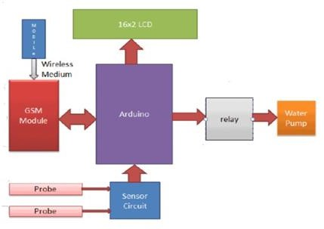

It used because it is smaller and takes less space. The real-time clock module is connected to the Hygrometer sensors are usually used in smart garden watering system. However, they are known for corroding quickly, particularly if watering is required every day. This system takes advantage of RTC to trigger the watering of an herbal garden. The major components used in this project as shown in figure 2 are: 12V power pack, real time clock, relay, buzzer, and Arduino Nano. An Arduino. The Arduino is programmed to turn ON the pump at a designated time. The pump is connected to the relay and 12V power through a 12mm PVC tube. The water supply is enabled through a 20 litre tank, enough to keep the watering for a few weeks. A float switch is connected to the bottom of the tank, that triggers an alarm if the water level goes below a critical level for the pump

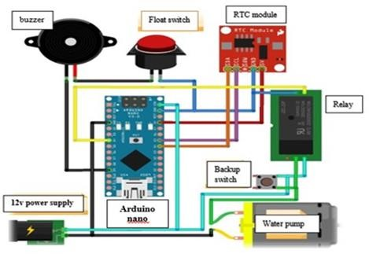

Automatic refill system provides a simple method to refill a fountain or an aquarium automatically when the water level is below a desired threshold. The reduction in water level might be caused by evaporation or water splash. The system consists of an electronic water pump, a float-switch and a microcontroller. When the water gets too low, the float switch sends a pulse to the microcontroller, and the microcontroller activates the pump. To operate a pump using an Arduino microcontroller, a relay is needed to switch on and off a separate power supply.

Aquarium auto refill with Arduino is a simple example of how to use a float switch, small liquid pump and a relay to refill an aquarium once the water level gets too low. But this same technique can be used for pet dishes, water fountains, or any other number of similar applications.

METHODOLOGY (DESIGN AND CONSTRUCTIOMN)

The design procedure involves determining the appropriate materials and components to be used in the circuit as well as their properties; which includes components values, voltage ratings and maximum current ratings. These could be actualized easily by consulting the data sheet provided by component’s manufacturer. The analysis of each unit will be carried out in detail, for example, the value of capacitor in the methodology

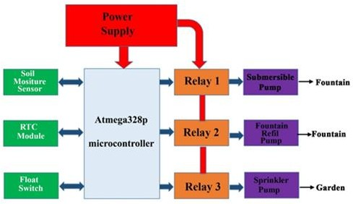

The ATmega328P microcontroller IC is programmed using the Arduino IDE software. The function of the RTC is to keep track of the system in real time and to trigger the system at a designated time. The moisture sensor senses the level of moisture in the soil. The water pump supplies water to the plants and refills the fountain. The submersible pump is submerged in the reservoir of the fountain and moves water to the aerator or fountain piece where the water emerges. Although this project uses ATmega328P microcontroller to control the water pumps, but the microcontroller cannot be used to trigger the pump directly. The relay is used to interface the microcontroller with the water pumps. The moisture sensor measures the level of moisture in the soil and sends the signal to the microcontroller when watering is required. Water pump supplies water to the plants until the desired moisture level is reached.

1. *ATmega328P Microcontroller IC*

ATmega328P is a low-power 8-bit microcontroller based on the enhanced RISC architecture. By executing powerful instructions in a single clock cycle, the ATmega328P achieves throughputs approaching 1MIPS per MHz allowing the system designed to optimize power consumption against processing speed.

The device is manufactured using Atmel high density non-volatile memory technology. The ATmega328P AVR is supported with a full suite of program and system development tools including: C compilers, macro assemblers, program debugger/simulators, in- circuit emulators, and evaluation kits.

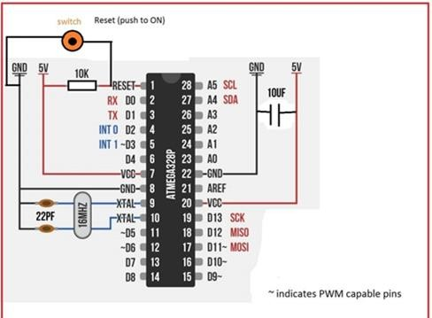

*2.Soil Moisture Sensor*

The soil moisture sensor module is used to detect the moisture level of the soil. It measures the volumetric content of water inside the soil and gives the moisture level as output. The moisture sensor consists of two probes that are used to detect the moisture of the soil. These two probes are used to pass the current through the soil to the LM393 comparator IC, and then the sensor reads the resistance to get the moisture values. This Moisture sensor module consists of a moisture sensor, Resistors, Capacitor, Potentiometer, Comparator (LM393 IC), Power and Status LED in an integrated circuit. The moisture sensor probes are coated with immersion gold that protects Nickel from oxidation.

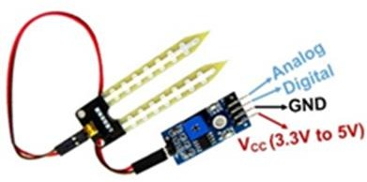

The DS3231 is a low-cost, extremely accurate I2C real-time clock (RTC) with an integrated temperature- compensated crystal oscillator and crystal. The device incorporates complementary metal oxide semiconductor (CMOS) battery to maintains accurate timekeeping when main power to the device is interrupted. The integration of the crystal resonator enhances the long-term accuracy of the device. A precision temperature-compensated reference voltage and comparator circuit monitors the status of VCC to detect power failures, to automatically switch to the backup supply when necessary and to provide a reset output signal. Additionally, the reset pin is monitored as a pushbutton input for generating a reset externally.

THANK YOU